East Lake High School
AVID Contract
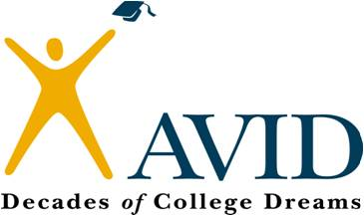

Advancement Via Individual Determination

Name of Student: Grade:
AVID is a program that prepares students for four-year college eligibility and success.

Student Goals:
- Academic success in high school/college preparatory classes.
- Successful completion of high school/college eligibility requirements.
- Enrollment in a four-year college or university after high school graduation.

Student Responsibilities:
- Maintain upstanding behavior, citizenship, and attendance in all classes.
- Maintain an AVID Binder, assignment records, and Cornell Notes.
- Complete all homework assignments and commit a two hours to homework each night.
- Maintain an average GPA of 3.0 or higher in all classes.

Student Agreement:
I agree to accept enrollment into the AVID elective class, which will offer academic support to me. I want to succeed and I understand I must take individual responsibility for my own success. I understand that in order to give fair consideration to my involvement with the program, I must commit to remaining enrolled in the AVID elective for at least one year and that I will be allowed to remain in the program only if I meet the student responsibilities outlined above. I also understand that studies show I will be most likely to demonstrate academic improvement if I remain in the program for at least three years.

Student Signature:

Support Statement: We agree to support our child in meeting and keeping up with these goals.

AVID Coordinator Signature: Parent Signature:

AVID Counselor Signature: Site Administrator Signature:

